**Project Initialization and Planning Phase**

|  |  |
| --- | --- |
| Date | 15 July 2024 |
| Team ID | 739795 |
| Project Name | Crop Prediction using Machine Learning |
| Maximum Marks | 3 Marks |

**Define Problem Statements (Crop Prediction Problem Statement Template):**

Agriculture is one of the main sources of income in India. There is need to improve the sustainability of agriculture with the rate of increase in suicides of farmer due to crop failure and less yield and losses. Hence, it is a significant contribution towards the economic and agricultural welfare of the countries across the world. The Problem Statement revolves around prediction of yield of crops considering different climatic conditions of India including various attributes. Goal of this project is to help the farmers to choose the suitable crop to grow in order to get the required yield and the profit. Need for the crop yield prediction is very much essential at this point of time for selecting the right crop.

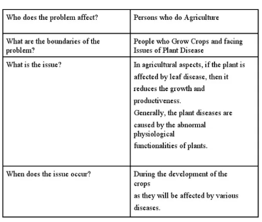

|  |  |  |  |  |  |
| --- | --- | --- | --- | --- | --- |
| **Problem**  **Statement**  **(PS)** | **I am**  **(Customer)** | **I’m trying to** | **But** | **Because** | **Which makes me feel** |
| PS-1 | A farmer | Predict the best time to plant my crops | The weather is unpredictable | It affects the growth and yield of the crops | Uncertain and anxious about my crop yield |
| PS-2 | an agricultural consultant | Provide accurate crop yield forecasts to my clients | There is a lack of reliable data on soil moisture levels | Soil moisture significantly impacts crop growth | frusted and unable to provide the best advice |